Dis-AM,S-Peru-Moche-Copper Mask

Moche Copper Mask, Sotheby’s

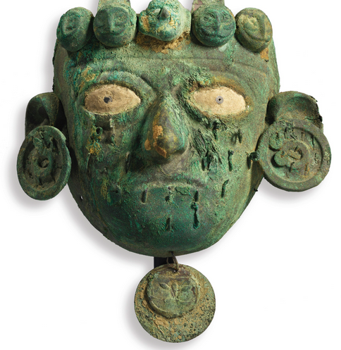  
Early/Middle Intermediate, ca. 300 B.C.-A.D. 300 the large eyes inlaid with shell and stern expression of tightly closed lips, adorned with separately attached earspools and a row of five owl's heads placed as a headband, the face covered with remains of attachments for further ornaments, and with a medallion suspended below the chin.  
Width: 7 3/4 in (19.7cm)

**Provenance**

Andre Emmerich Inc.  
Joyce Strauss Collection, acquired from the above

**Exhibited**

New York, *Sun Gods and Saints, Art of Pre-Columbian and Colonial Peru*, Andre Emmerich Gallery, December 6-31, 1969, no. 48, illus.

**Literature**

Alan Lapiner, *Pre-Columbian Art of South America*, New York, 1976, Fig. 349

**Estimate**

5,000 — 8,000

[USD](http://www.sothebys.com/en/auctions/ecatalogue/2015/african-oceanic-n09347/lot.4.html)

**LOT SOLD.** 8,750 USD **(Hammer Price with Buyer's Premium)**